Experiment 1D: Environmental Audit of Possible Phosphate Contamination

Learning Outcomes:
Upon completion of this experiment, you should be able to:
- Accurately prepare a set of standard solutions
- Use multiple analyses to determine the precision of the technique
- Operate a UV-visible spectrophotometer and interpret the output data
- Apply the Beer-Lambert law
- Present instrumental output in properly labelled tables
- Plot a calibration graph, determining the equation for the best fit line and the R² value
- Use the calibration graph to determine the concentration of unknown solutions and interconvert concentration units

Safety:
Hazards associated with this laboratory are listed in the Risk Assessment Form available in the lab and on LEARN.

Prelab:
- Watch the video associated with this experiment. In the video, the demonstrator will make some deliberate errors when preparing the solutions and measuring the absorbance values. While watching the video list (at least) three errors made.
- In the lab you will be provided with a 2.00 x 10⁻³ mg mL⁻¹ stock standard solution, a graduated 10 mL pipette and a number of 50 mL volumetric flasks. In your lab book, calculate the concentration of phosphorus in each of your standards in mg L⁻¹, given the dilution procedure given in Part 1 of the procedure.

Introduction:
The aim of your experimental work is to determine the phosphate concentration in a sample of diluted cow urine provided.
Phosphorus cycle
Phosphorus is an important element. It is essential for life, as it is found in the backbone of DNA, in enzymes, in cells, and in fats. So, what are the sources of phosphorus in the biosphere?
Living organisms can get elements like oxygen and carbon from the atmosphere, but phosphorus is not obtainable in this way. Rather, phosphorus is abundant in rocks and the earth’s crust as insoluble solids, and so is not readily accessible by organisms.
Phosphorus is made available through the phosphorus cycle (Figure 1).
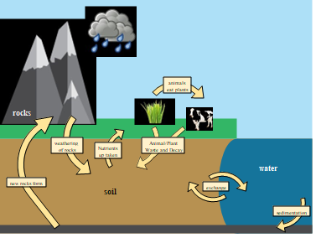
Figure 1 – The phosphorus cycle.
With weathering of rocks, phosphorus becomes water soluble and finds its way into rivers, oceans, and other bodies of water. With this increased mobility phosphate becomes available in water and soil and therefore to plants and animals.
As plants and animals die and decay, or as phosphorus-containing material is excreted as urine or faeces, phosphates are returned to water and soil to be up taken by other plants and animals, or eventually finds its way into sedimentary rocks, completing the cycle.
Man’s influence on the natural phosphorus cycle has been, and is, great. Phosphorus rocks are mined as a source of fertiliser, and therefore we have artificially increased its mobility. This extra phosphorus in the environment will eventually find its way into natural waters. This in turn will accelerate the growth of algae (Figure 2), the so-called ‘algal bloom’. This process in turns results in eutrophication, where other organisms are oxygen-starved as the algae consume all the dissolved oxygen in the water.
It is therefore important to monitor levels of phosphate in water - if these levels get too high, then the associated problems of eutrophication will occur.
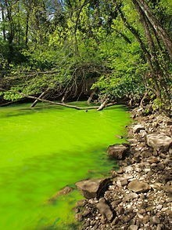
Figure 2 - Eutrophication through algae growth.

Problem to be Solved:
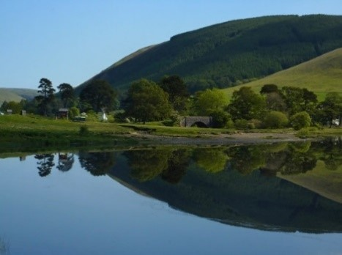
A farmer is planning to introduce 100 cows to fields surrounding the Loch of the Lowes. This is a currently un-spoilt part of Scotland – the loch has no surrounding industries that contaminate the water.

These cows will need to pee – on average 13 litres a day, each! If 100 cows are surrounding the fields, and all the urine produced daily needs to go somewhere, a large amount of urine will eventually end up in the loch. Urine contains a considerable amount of phosphate, and therefore a potential environmental problem could arise.
With the introduction of cows to the surrounding fields, and assuming all urine produced ends up in the loch, how long will it take for the phosphate concentration in the water to reach an unsafe level?
To answer this questions we will obviously require some relevant data. The volume of the Loch of the Lowes is 5.5 x 10⁶ m³ and has a natural phosphate concentration of 5.00 µg L⁻¹. The safe limit of phosphate in natural waters, as set by the Scottish Environmental Protection Agency, is 0.025 mg L⁻¹.

Phosphate determination:
You will determine the concentration of phosphate in the cow urine sample using UV-visible spectroscopy. Phosphate in water samples can be quantified by observing the blue colour that arises when a solution of molybdate and phosphate (as PO₄³⁻ or as HPO₄²⁻, the major species in solution) is reduced by tin(II) chloride. The structure of the product formed is not precisely known, but it involves the formation and subsequent reduction of a heteromolybdate:
12 [Mo(VI)O₄]²- + PO₄³⁻ + 12 H₂O $→$[PMo(VI)₁₂O₄₀]³⁻ + 24 OH⁻
2 [PMo(VI)₁₂O₄₀]³⁻ + Sn²⁺ $→$2 [PMo(VI)₁₁MoVO₄₀]⁴⁻ + Sn⁴⁺

Although the composition of the blue complex is uncertain, the intensity of the blue colour formed ($λ$max ~ 880 nm) is proportional to the original phosphate concentration and can be measured using a UV-visible spectrophotometer and application of the Beer-Lambert law.

Procedure:

Part 1: Construction of the Calibration Graph
Take six 50 cm³ volumetric flasks and pipette 2, 4, 6, 8, and 10 cm³ aliquots of the phosphate standard respectively into five of them; the sixth flask has no phosphate added and serves as a blank. Fill each flask to approximately half-full with deionised water. Remember to take a note of the concentration of the phosphate standard. Into each flask pipette 2 cm³ of the ammonium molybdate solution and swirl to mix. Pipette 2 cm³ of the tin(II) chloride solution into each flask, fill to the mark with deionised water and mix thoroughly. Leave the flasks to stand for 30 minutes.
After 30 minutes, measure the absorbance at 880 nm of each of the six solutions, beginning with the blank and measuring the others in order of increasing phosphate concentration. Before each measurement wash out the spectrophotometer cell with deionised water then with a little of the solution to be measured, prior to filling the cell.

Part 2: Preparation and analysis of samples
You are provided with a diluted sample of cow urine – this has been pre-diluted by a factor of 10.
In triplicate, pipette 10 cm³ aliquots of the urine samples into 50 cm³ volumetric flasks and fill with deionised water until approximately half-full. Add 2 cm³ of each of the ammonium molybdate and tin(II) chloride solutions as described in Part 1, and fill to the mark with deionised water and leave for 30 minutes.
After 30 minutes measure the absorbance of the solutions using the same spectrophotometer and cell as were used for the standards.

Treatment of data
- Construct a table of absorbance values against standard solution concentrations, and a separate table of absorbance values for the prepared unknown solutions.
- Using your experimental data, plot a calibration graph of absorbance (y-axis) vs. standard concentration and determine the best straight line. Use this calibration line to determine the concentration of phosphate in each of the diluted unknown solutions. Hence calculate the concentration (mg PO₄³⁻ per litre) of the cow urine (remember to account for the dilution factor).

Results:
You have now determined the concentration of phosphate in the cow urine samples.
Using the information given previously, and your measured value of phosphate in cow urine, answer the following question:
With the introduction of cows to the surrounding fields, and assuming all urine produced ends up in the loch, how long will it take for the phosphate concentration in the water to reach an unsafe level? Evaluation: How realistic is your answer? What assumptions have you made in your calculations? If we are to present an environmental report then we should be aware of all the facts. What are the most important points of information that we have NOT been told during this analysis?

Assessment:
Please complete the associated quiz on LEARN within 1 week of completing the experiment.

